**YouTube Demonstration Video:** [**https://youtu.be/0Vugu2DB9Is**](https://youtu.be/0Vugu2DB9Is)

**Lab 3 Schematics:**

MPU6050 6-DOF gyroscope and accelerometer is connected to the ESP32 micro-controller unit. Red LEDs and Green LEDs are also connected. Green LEDS indicate whether the system is active or deactivate. Red LEDs turn on when the system detects a theft. I used pins 22, 23 for SCL, SDA; pins 12 and 13 for Red and Green LEDs. A 3.3V pin is used to power the MPU6050 gyroscope and accelerometer.

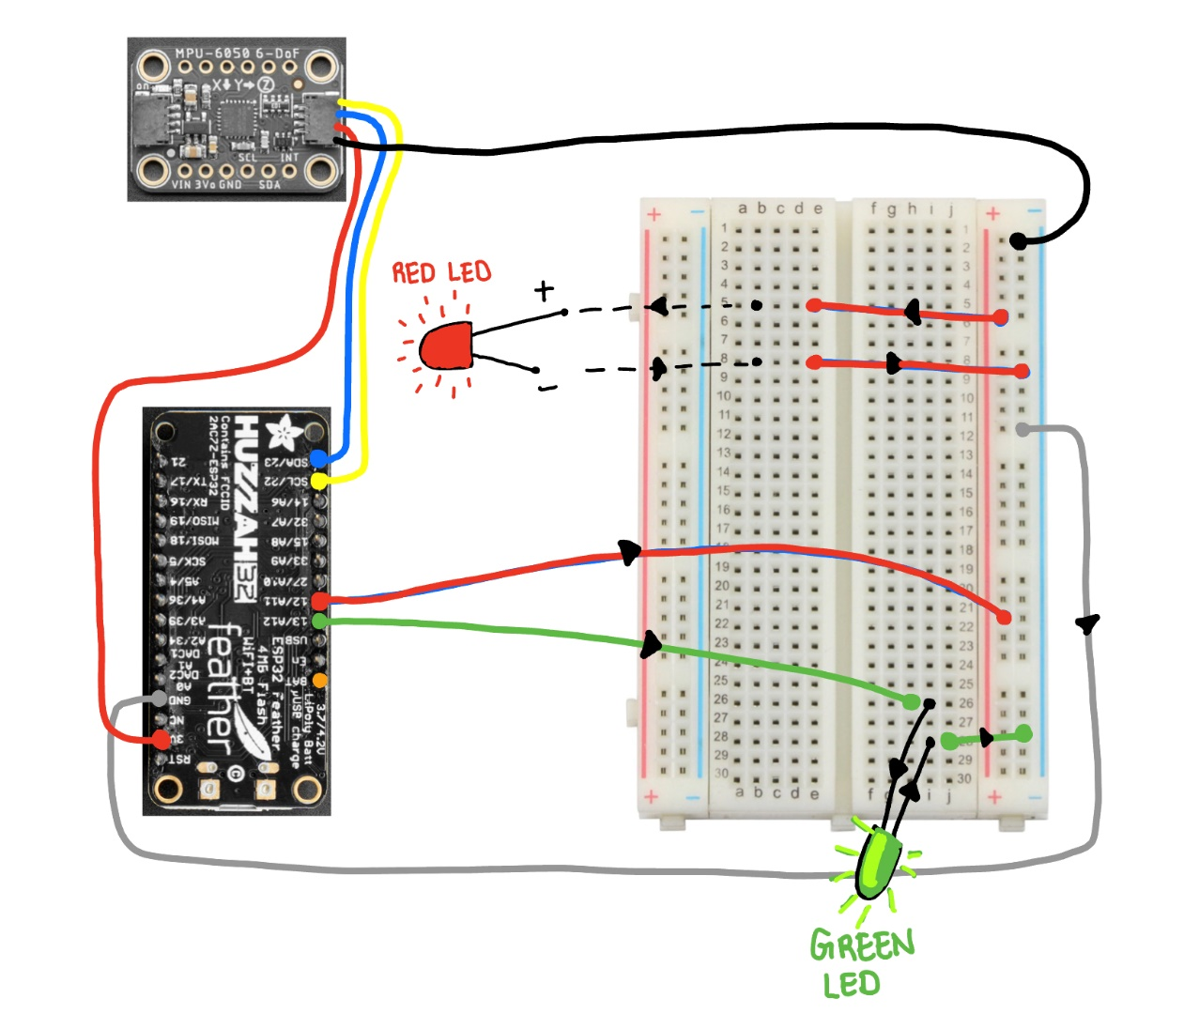

**Here is a high-level logical sequence of steps that take place when executing the motion_detection.py code:**

*Note:* I was not able to use Circuit Python adafruit_mpu6050, so I used another code recommended in the Piazza group called mpu6050.py. This file is also attached in this deliverable. Slight modifications to this file have been made (acceleration values are divided by 16384 for 2g’s).

1. Connect to Wi-Fi – Note that the SSID and Password have been removed for obvious reasons, but you would have to replace them with your SSID and Password for that network
2. Initialize the Real Time Clock – this is mainly used for getting the seconds clock running. We will use the seconds counter to fetch status of Activate or Deactivate from ThingSpeak every 30 seconds, which is triggered from Google Assistant
3. Initiate the timer and initialize the response to Deactivate – the system will be stay in this state until it receives Activate signal
4. After receiving the Activate signal, the MPU6050 sensor is calibrated – here, I calibrate using 10 samples, but this could be as high as 100 samples. Bias of the values is estimated and offset (e.g., acceleration in z was 0.91g, and bias was determined to be 0.09g)
5. Once Calibrated, the system will stay in a loop, measuring the acceleration values. It gets triggered it Acceleration values in any direction surpass 1.5g. When that happens, it sends this to the WebHooks API, where it is triggered to send notifications to the IFTTT app on my iPhone.
6. Every 30 seconds, the system checks for the Google Assistant field in ThingSpeak. If motion control deactivate is sent, then the system stops.